**Basic Sovereign Debt Analysis**

Project Author: Jakov Vodanović

# Introduction

In this small project, I aim to explore the nature of indebtedness, credit ratings, and the relationships between credit ratings of countries and their indebtedness, measured in terms of debt to GDP and interest paid to GDP. I will address three crucial questions:

1. Relationship Between Credit Rating and Debt to GDP / Interest Paid to GDP

* What is the relationship between credit rating and debt to GDP?
* What is the relationship between credit rating and interest paid to GDP?

1. Normality of SWI (Sovereign Wikirating Index) Credit Rating

* Is SWI credit rating normally distributed?

1. Relationship Between Debt to GDP and Interest Paid to GDP

* What is the relationship between debt to GDP and interest paid to GDP?

# Data Sources

I obtained my data from the following sources:

Debt to GDP: [IMF Data](https://www.imf.org/external/datamapper/CG_DEBT_GDP@GDD/CHN/FRA/DEU/ITA/JPN/GBR/USA)

Interest Paid to GDP: [IMF Data](https://www.imf.org/external/datamapper/ie@FPP/ITA)

SWI Credit Rating: [Wikirating](https://www.wikirating.com/list-of-countries-by-credit-rating/)

# Data Processing

Here are the steps I took to process and analyze the data:

Data Import and Organization: I imported the data and organized it in R. This involved removing any missing values and merging data from different sources.

Mapping Credit Ratings: To measure correlations, I assigned numeric values to credit ratings. Sovereign Default was coded as 0, and AAA+ as 22, with higher numbers indicating higher credit ratings.

# Findings

## Relationship Between Credit Rating and Debt to GDP / Interest Paid to GDP:

Correlation between credit rating and debt to GDP: -0.4119688

Correlation between credit rating and interest paid to GDP: -0.2858445

A higher credit rating is associated with a lower debt-to-GDP ratio, indicating that countries with better credit ratings are more likely to manage their debts effectively. It's important to note that the correlations are not very high, and the analysis is influenced by the unique economic conditions of 2020 relating to the pandemic.

## Normality of SWI Credit Ratings:

I performed a chi-squared test to assess the normality of SWI credit ratings, resulting in a very low p-value (7.069876e-05). This indicates that the ratings are not normally distributed. The histogram below shows that most countries have lower to middle credit ratings, with very few defaults and a few countries with very high ratings.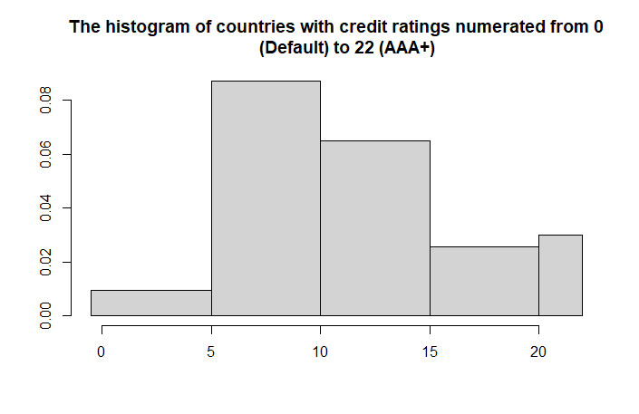

## Relationship Between Debt to GDP and Interest Paid to GDP:

The correlation between debt to GDP and interest paid to GDP is positive but not very high (0.3572013). This suggests that not all debt is the same, and some highly indebted countries may pay less interest due to lower interest rates. For example, India had a 55.1% debt-to-GDP ratio but paid 5.254% of GDP in interest, while the United States had a 118.27% debt-to-GDP ratio but paid only 2.596% of GDP in interest.

# Conclusion

While these initial findings are somewhat insightful, further research and analysis across time and economic conditions are needed to draw more robust conclusions. The relationship between credit ratings, debt, and interest payments is complex and subject to various external factors.